

FOODIE Web app

Project Management Plan



February 25, 2023

iti qa team

Version 01

**Revision History**

Note: The revision history cycle begins once changes or enhancements are requested after the document has been baselined.

|  |  |  |  |  |  |  |
| --- | --- | --- | --- | --- | --- | --- |
| **Comment** | **Review Date** | **Reviewed by** | **Date** | **Version** | **Description** | **Author** |
| Add test,configuration, review strategy | 21/2 | Sohib | 20/2 | 01 | Initial version | Menna |
|  | 23/2 | Abdullah | 23/2 | 01 | test,configuration, review strategy | Mahmoud |

**Table of Contents**

**1. Introduction.**

**2 Project Overview.**

**3 Scope Statements.**

**4. Goals and Objectives.**

**5. Assumptions & Constrains**

**6. Project Life Cycle**

**7. Tools**

**8. configuration management strategy**

**9. testing strategy**

**10. Review strategy**

**11. Risk Management Plan**

**12. Project Monitor Plan**

**13. Team Structure**

**14. Project Plan Approval**

# 

# **Introduction**

This PMP describes the project management processes that <our team > will follow during execution of the <foodie web app > project. The project’s processes will align with plans and processes of the Project Management Accountability System (PMAS) Guide New processes will be defined for any management areas not covered by the PMAS Guide. This PMP will govern the management practices across the life of the project. As those practices evolve, this document will be updated to reflect the changes.

## **2. Project Overview**

Provide an executive summary of the project objectives, the product to be delivered, major work activities, major work products, major milestones, required resources

## **3. Scope Statements**

Foodies is a web based app provides a good source of restaurants so users can discover and order their food

|  |  |
| --- | --- |
| **In Scope** | **Out of Scope** |
| Login Page with the following features :  User email or ID & strong password  Admin email or ID & strong password  Use forget password feature after 3 times | Login feature using mobile number or OTP |
| Sign up page using User email & strong password | Payment methods whether mastercard or visa and integration with any third party |
| integration,system and acceptance testing | unit testing |
| searching engine provide nearby restaurant according to user region | Credit card processing system. |

## 

## **4. Goals and Objectives**

Design high quality Foodie Web App take in consideration the following criteria

1. Satisfy the customer by continuous delivery and early feedback
2. Review all work Products
3. Stick with all deadlines without any delay
4. Collaboration with customer for any updates
5. Apply traceability for all work products

**5. Assumptions & Constrains**

|  |  |  |  |
| --- | --- | --- | --- |
| no. | Assumptions | Customer comment | Status |
| 1 | User IDs will be entered manual |  |  |
| 2 | User Password must contain more than 8 characters with special characters | approved | Close |

|  |  |  |  |
| --- | --- | --- | --- |
| Status | customer comment | Constrains | no. |
|  |  | It should be web-based App | 1 |
|  |  | User should add unique ID | 2 |
|  |  | Admin features should be added | 3 |

## **6. Project Lifecycle**

We are following the Waterfall Model But we are also using some Agile methodologies with the following popular approaches:

* Daily stand-up meetings
* Using task board & Burndown charts

# **7. Tools**

1. configuration management : Github
2. Schedule: Jira
3. Task board: jira
4. Ui Wireframe: Miro
5. Development: VS code
6. Testing:Google sheet

# **8. Configuration management Strategy**

our purpose of configuration management is to identify, track and protect the project’s deliverables or products from unauthorised change. Configuration management is a discipline that gives precise control over the project

we are using:

1. distributed version control like Github site to focus mainly about:
2. specify the versions of products in use and in existence and hold information on their status, who owns them and relationships between them
3. configuration item list (CIL):

* to maintain the last versions of the documentations
* to maintain traceability of the work products

1. our folder structure as following

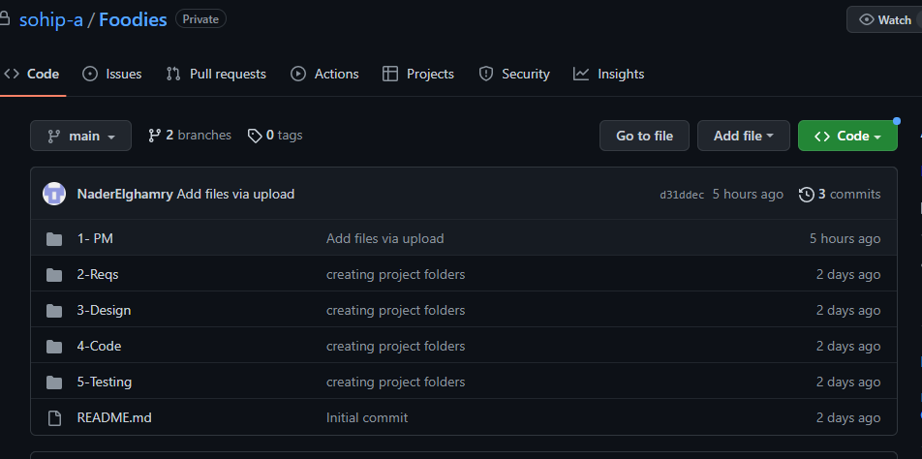

# **9. Testing Strategy**

Our test strategy is a set of instructions to explain and detail the test design and how to perform the test. An arrangement describes the approach for testing and answers what is required to complete and how to achieve it.

* Clearly stated goals:

Your testing activities must have clear and explicit aims. This will assist you in focusing your efforts and ensuring that you are testing the right things.

* Thorough testing:

Your testing plan should cover all product areas, including functionality, performance, security, and usability.

* Initial testing:

It is far easier and less expensive to address problems early in the development process, so it is critical to begin testing as soon as feasible.

* Collaboration:

It is required because testing must be done in collaboration. To guarantee that everyone is working toward the same goals, developers, testers, and other stakeholders must work closely together.

* Continuous testing:

Rather than being a one-time event, testing should be an ongoing process. This ensures that problems are identified and handled as soon as possible.

* User focus:

Your testing efforts should ensure that the product meets the needs and expectations of your users.

* Our testing strategy include:
* Purpose (defined by the user story).
* Objectives (test cases).
* Scope (what needs to be tested).
* Methods (how tests will be run).
* Our testing types and levels include:
* integration testing
* system testing
* acceptance (beta & alpha)
* functional and non-functional

# **10. Review Strategy**

Our purpose of review is to make examination to every work product in the project that may examined by a developer, tester It provides a better view on the work product

Types of reviews using:

|  |  |  |  |
| --- | --- | --- | --- |
| **Reviews** | **document** | **Frequency** | **Objective** |
| Informal review | Null | daily | Review the “big Picture of work product” |
| Walkthrough | Minutes of meeting | After finishing work product | The author explains his work product in details |
| Formal review | Check list Based | Weekly | Check the main points must be in selected work product |

we mainly focus on:

* Defect Prevention is the main goal of the software as well as look out for the functionality of the software.
* Review of the requirement specifications should be done carefully so as to evaluate the software as per required.
* The list of questions should be clarified.

# **11. Risk Management Plan**

# Will be explained in another document as follow:

https://github.com/sohip-a/Foodies/blob/main/1-%20PM/Risk%20Management%20Policy.doc

# **12. Project Monitor Plan**

Project Monitoring refers to the process of keeping track of all project-related metrics including team performance and task duration, identifying potential problems and taking corrective actions necessary to ensure that the project is within scope, on budget and meets the specified deadlines

* hold daily standup meetings to follow up team progress & impedings
* Establishing clear deadlines will be helpful for measuring progress. Being clear about deadlines can help workers stay on track and complete tasks
* use real time Dashboards with task lists
* use traceability matrix between all project phases

# **13. Team structure**

|  |  |
| --- | --- |
| **Name** | **Role** |
| Sohib Ahmed | Team Leader |
| Nader Abdallah | Developer and Tester |
| Mahmoud el deghidy | Developer and Tester |
| Menna Hesham | Developer and Tester |
| Abduallah | Developer and Tester |

**Approval Signature**

Signed: _________________________________________________________________________

Project Manager Date

Signed: _________________________________________________________________________

Customer Date